SAMPLING GUIDE

1. When? At the drain period closest to when sampling is scheduled.
(a) Before any make-up or top-up oil has been added.
(b) When lubricating system is hot and oil has circulated for some time.
(c) After purging the sample line (where applicable).
(d) On a regular basis as part of an improved maintenance programme.

2. With what? The correct tools are important.
(a) Drain Stream Sampling.
- Allow one third to half of the oil to drain, then take sample. This ensures that the sample is representative of the oil in the lubricating system.
- Fill sample bottle to fill line on neck of bottle.
Caution: Oil may be extremely hot.
(b) Sampling Pumps. Hand-operated using a vacuum to draw oil through
plastic tube into sample bottle (contact Caltex CSC to purchase pump)
- Suitable for when oil is NOT being changed and an in-service sample is required or for obtaining samples from final drives.
- Ensure that a NEW length of tube is used for each sample taken.
- One sample bottle required for each component being sampled.

3. And then? (a) Complete the sample details form in full (copy below):

Serial No: Obtain from previous report, or leave blank for new units and number will be assigned.
Name: Use equipment owners name.

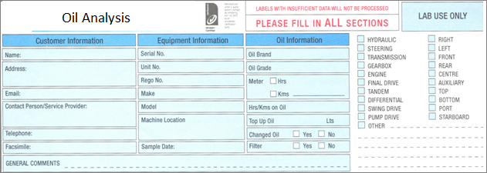

NOTE: This Sample details form is also available on-line at www.oilanalysis.co.nz and clicking on “How to print labels” and is the preferred option as once initially completed for a component, the information is retained and any future samples for the same component only require the date and km/hour details changed. These forms can then be printed off and submitted with the sample.
(b) Ensure that a copy of the label is placed in the mailing container.
(c) Place sample bottle in post-paid, pre-addressed mailing container
and ensure caps are tight.
(d) Send it promptly to laboratory (by NZ Post).

