**How to print an Oil Sample label directly from the Oil Analysis Website**

The following procedures detail how to create and print an oil sample label for Oil Analysis from the website www.oilanalysis.co.nz

By creating the label on-line, you will not have to manually fill out the sample label provided with the kit each time you submit a sample. Instead, once it is completed on line, it is just a matter of updating the information that has changed (ie: kms and hours) and printing off and submitting the label with the oil sample bottle.

1. Once you have signed onto the Oil Analysis website, move the cursor over the Manage Equipment & Fluid Analysis fields and then move your cursor over Print Sample Labels and then click Print Sample Labels.

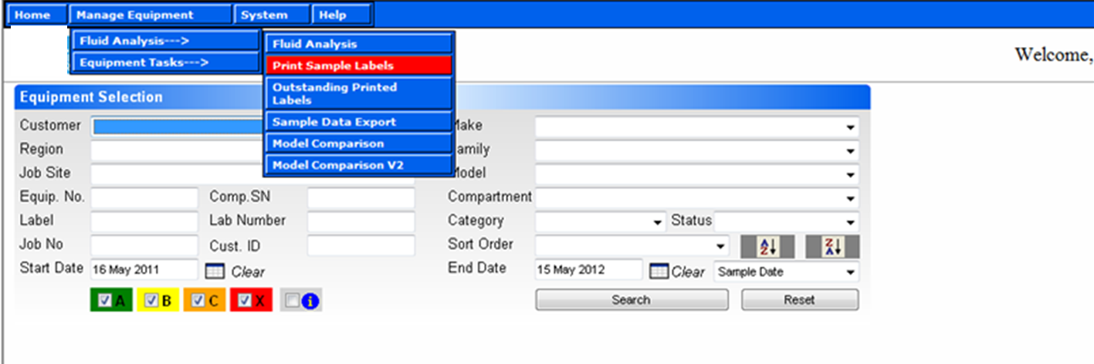

1. In the ***Customer field*** click on the *drop down arrow* on the right and select your C***ompany Name***. Then select the ***Serial No / Unit No*** for the piece of equipment you wish to analysis, using the *drop down arrows* on the right.
2. Then click on the ***Compartment SN*** box. The ***Region*** and ***Job Sites*** will automatically populate.
3. Once these fields are populated please enter the kilometres/hours in the *Meter Reading\** field.

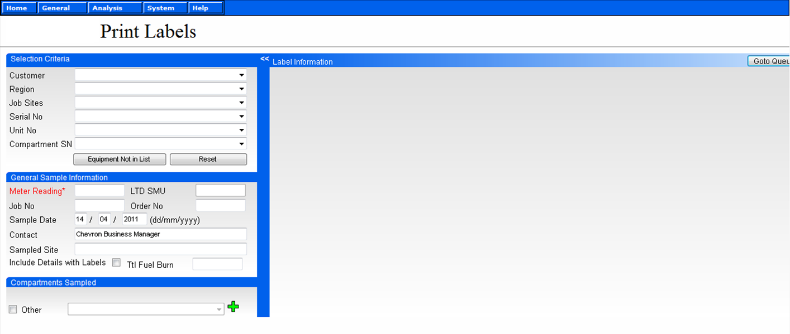

*Meter Reading*

*Customer Name*

*Serial No/Unit No*

*Compartment SN*

1. Under Compartment Sampled place a tick in the appropriate box the oil sample has come from ie: ***Engine, Differential, Transmission, Other*** (If it hasn’t automatically populated).

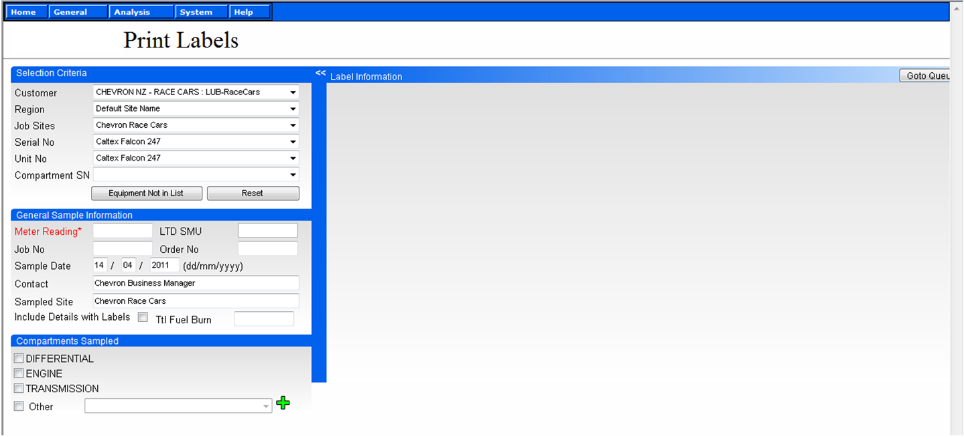

1. If the compartment is not visible then place a tick in the ***Other*** box and this will load a complete list of components in the drop down box to the left of the ***Green +***. Once you have clicked on the component you wish to add, re-click on the ***Green +*** and this will load the component with the other components as shown above.
2. Now place a tick in the box next to the component(s) you wish to analysis.
3. This screen will now appear, and on the right please complete all the information required highlighted in *Red.* When selecting Oil Type use the drop down arrow to the right selecting the product that is currently being used. Please make sure you click in the Y or N buttons if the *Fluid* or *Filter* has been changed or not.

*Meter Reading\** is the total number of kilometres/hours the machine has travelled, the *Fluid Hours\** is the length of kilometres/hours the oil has been in service (ie: since the last time it was changed).

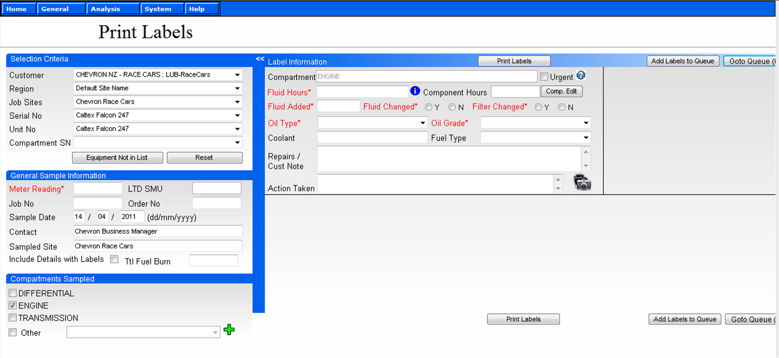

1. Once all the appropriate boxes have been filled out you can then click on the ***Print Labels*** button and the label will then appear on a separate screen, it then can be printed off and sent in with the oil sample bottle.

All fields that are highlighted in *red* must be filled out otherwise the label cannot be produced.

***Job Number/Order No:*** Are for your reference purposes only and if it is not applicable they can be left blank.

***Repairs/Cust Note:*** This is if you wish to add any comments that will help the lab when the analysis is being interpreted.

***Include Details with Labels:*** This shows all the previous oil sample history (optional).

***Ttl Fuel Burn:*** This is for engines only and is to be entered as a number, ie the number of litres of fuel (diesel/petrol) that has been consumed during the period the oil has been in service (optional). A view of what the printed label will look like.

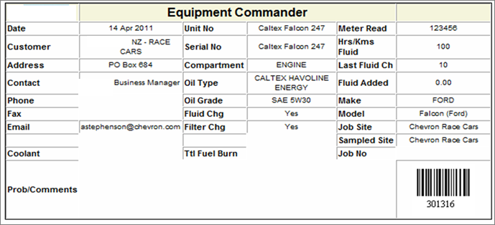

1. To return to the Fluid Analysis screen, move your cursor over Manage Equipment – Fluid Analysis and then click on Fluid Analysis to the right.

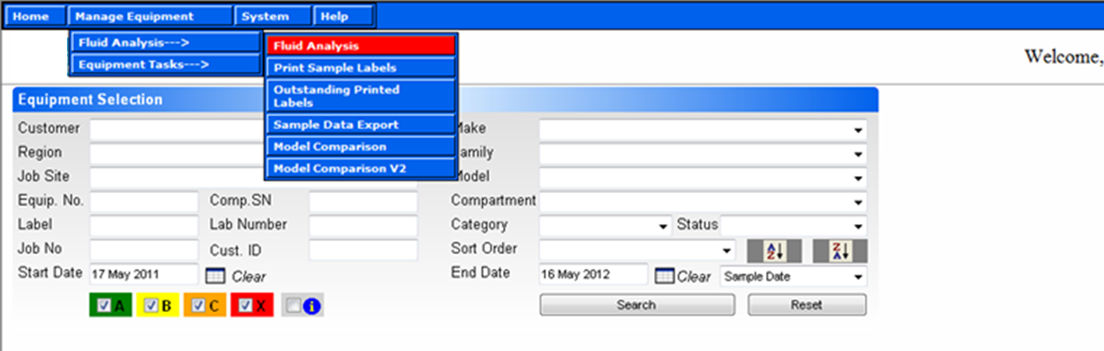

Should you require any assistance or have any questions regarding creating the labels, please contact Caltex on Free Phone 0800 733 835 and select Option 3 for Lubricants Technical.