**How to access and view Oil Sample Reports on the Oil Analysis Website**

**The following screen shots are an introduction on how to open and access your results in the Oil Analysis web site www.oilanalysis.co.nz**

1. **Login Screen**

Enter your ***User Name*** and ***Password*** in the appropriate fields and click on the ***Login*** bar.

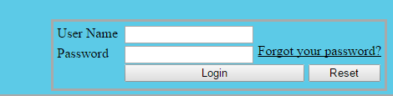

2. **Note:** The first time you access the site there will be a disclaimer you will need to click on and agree with, following this the Oil Analysis Screen will open, and the disclaimer will not appear again.

***You will also be asked to submit a new password. Please follow these instructions carefully.***

3. **Oil Analysis Screen**

When the screen opens your name will appear in the top right hand header. In the ***Customer*** box, select

Your company name.

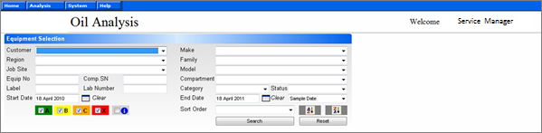

4. To view all the lab results for the last 12 months, click on the ***Search*** button. Records can be further filtered by changing the ***Start Date***, or click ***Clear*** to see all records but leave the End Date as today’s date.

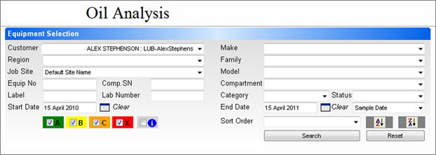

5. To view an individual piece of equipment, click on the ***Compartment*** section on the right of the screen. By using the drop down arrows select the piece of equipment you wish search on individually.

6. Alternatively, having accessed the entire fleet, you can view an individual piece of equipment by clicking on the number in the ***Serial No*** column.

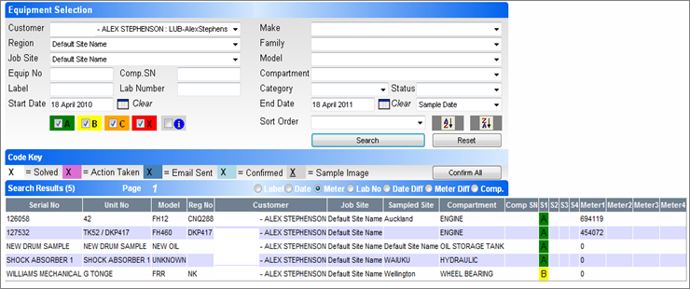

7. To view any of the of the individual sample reports, place the curser on the evaluation code under ***S1*** and left click the mouse to view the drop down box and select the function required.

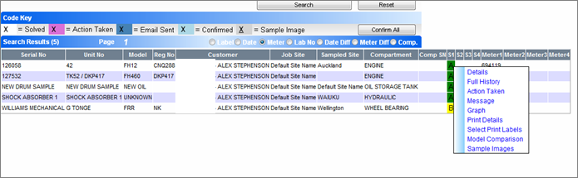

8. By clicking on ***Details*** this screen then opens up which shows the full test result, by moving the cursor over the figures shown below each element is highlighted showing a full description of its name. The numbers are ppm (parts per million) except where it is shown as a % percentage.

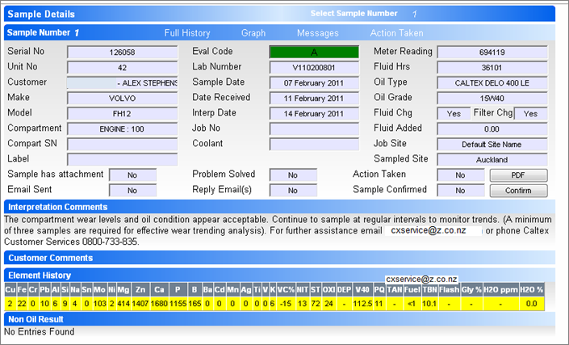

9. By clicking on ***Full History*** this screen then opens up, which shows all the previous test results. You will now be able to compare the latest test result with all the previous results.

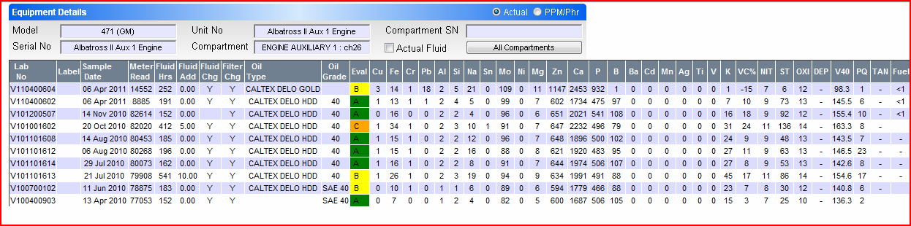

10. To print the result click on the ***Print Details*** and this will default to the printer connect to your computer or to the network printer (ie: shared printer).

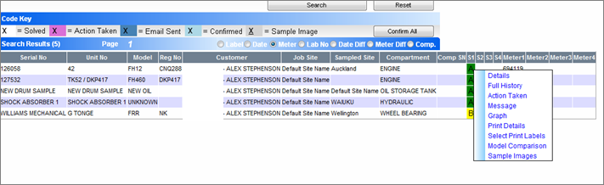

11. To log out once you have completed viewing the test results in Oil Analysis, move the cursor over System and move down until Logout is displayed and then click here.

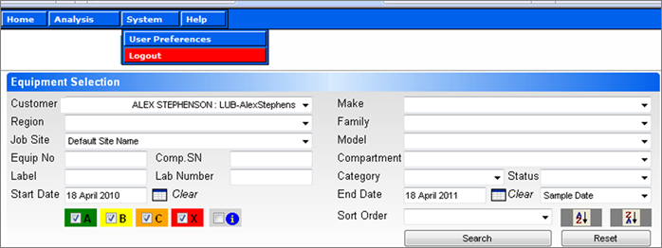

Should you require any assistance or have any questions regarding navigating the Oil Analysis website please contact Caltex on Free Phone 0800 733 835 and select Option 3 for Lubricants Technical.